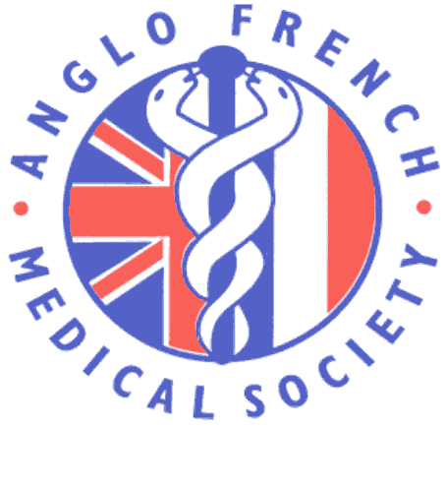 AFMS Medical French Weekend
Student Competition to win a fully paid place at the AFMS Annual Conference in Montpellier 18 – 21 September 2019
Students that attended the Medical French Weekend Course 12-14 April 2019 in Lille will have the chance to win a fully paid place at the AFMS annual conference in Montpellier, from 18th to 21st September 2019. The prize also includes a grant covering travel to conference of up to £75. One prize place is available.
To enter the competition, students can an article on their experience of the Medical French Weekend Course 2019. Email to medicalfrenchcourse@anglofrenchmedical.com Closing date 31 May 2019.
At Montpellier, the winner will give a 15 minute talk at conference on a medical related topic and will be entered into the competition to win the James Tudor Prize.
AFMS-AMFB main conference, September 18th to the 21th September 2019
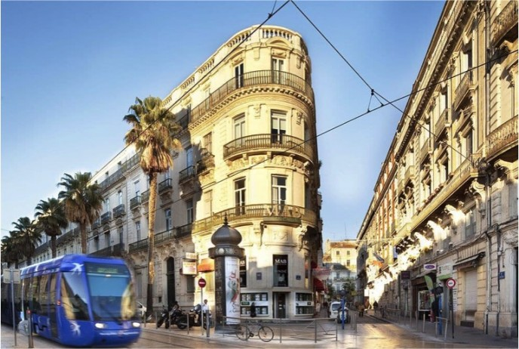
www.anglofrenchmedical.com

