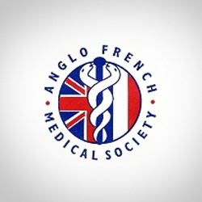

Anglo-French Medical Society

27th Medical French

Residential Weekend Course

12-14 April 2019

Lille, France

A unique opportunity to experience Medical French in France. Teaching in partnership with the Medical Faculty of Université Catholique de Lille

Extensive course handbook provided

All levels of French-speaking accommodated

Early booking advised, details on [www.anglofrenchmedical.com](http://www.anglofrenchmedical.com)

or contact Christine Greenwood on 0151 529 5885 [c.greenwood@liverpool.ac.uk](mailto:c.greenwood@liverpool.ac.uk)

Price includes 2 nights hotel accommodation, all meals including a gala dinner, and guided tour of historic Lille

Doctors £585 FY1/2 £485 Students £285 (shared room)/£315 (single)

Doctors booking prior to 31 January 2019 receive a £30 discount.