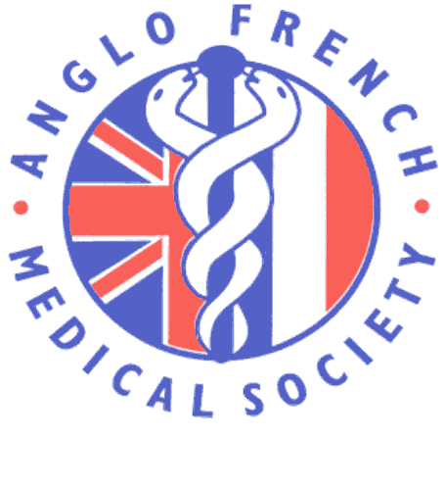 AFMS Medical French Weekend
Student Competition to win a fully paid place at the AFMS Annual Conference in Cardiff September 2018
Students that attended the Medical French Weekend Course 13-15 April 2018 in Lille will have the chance to win a fully paid place at the AFMS annual conference in Cardiff, from 26th-29th September 2018. The prize also includes a grant covering travel to conference of up to £75.
To enter the competition, students can an article giving feedback on their experience of the Medical French Weekend Course 2018 , including any suggestions about improvements and ideas for publicity. Email to medicalfrenchcourse@anglofrenchmedical.com Closing date 31 May 2018.
At Cardiff, the winner will give a 15 minute talk at conference on a medical related topic and will be entered into the competition to win the James Tudor Prize.
AFMS-AMFB main conference, September 26th to the 29th September 2018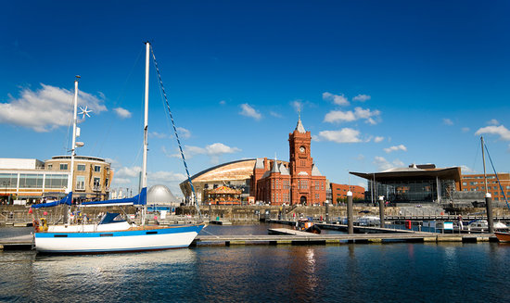
www.anglofrenchmedical.com

