Medical French Weekend Student Competition to win a fully paid place at the AFMS Annual Conference in September 2016
Students attending the Medical French Weekend Course 1-3 April 2016 in Warwick will have the chance to win a fully paid place at the AFMS annual conference in September 2016, which is taking place in Windsor. The prize also includes a grant covering travel to conference of up to £75.
To enter the competition, students must submit an article giving feedback on their experience of the Medical French Weekend Course, including any suggestions about improvements and ideas for publicity.
The article should be no longer than 800 words and should be emailed to Dr Zara Bieler by 16th April 2016 on zarabieler@me.com.
At Windsor, the winner will give a 15 minute talk at conference on a medical related topic and will be entered into the competition to win the James Tudor Prize.
A total of six students at conference compete for the James Tudor Prize, see website for details.
www.anglofrenchmedical.com/meetings/
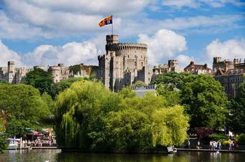
Windsor 21st to the 24th September 2016

