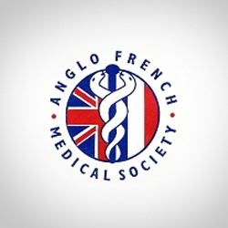

Anglo-French Medical Society

25th Medical French

Residential Weekend Course

21-23 April 2017

Lille, France

**To celebrate our Silver Anniversary, the course will be held in France for 2017 only**

A unique opportunity to experience Medical French in France. Teaching in partnership with the Medical Faculty of Université Catholique de Lille

Extensive course handbook provided

All levels of French-speaking accommodated

Early booking advised, details on [www.anglofrenchmedical.com](http://www.anglofrenchmedical.com)

Price includes 2 nights hotel accommodation, all meals including a gala dinner, 2 day travel pass and guided tour of historic Lille

Doctors £550 FY1/2 £450 Students £280 (or £260, twin room)